**Exercise 1: Mocking and Stubbing**

Added dependency, code and classes to check

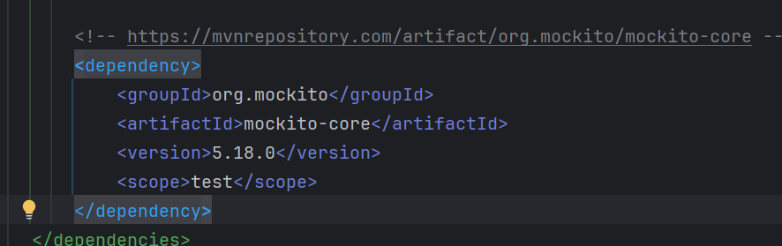

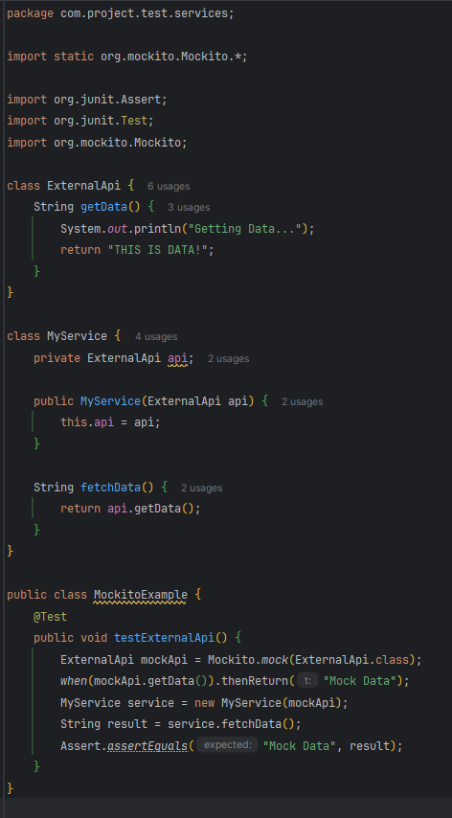

Output,

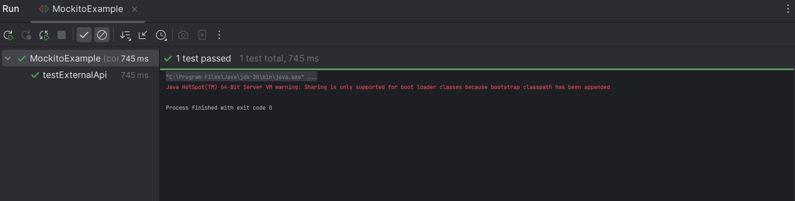

**Exercise 2: Verifying Interactions**

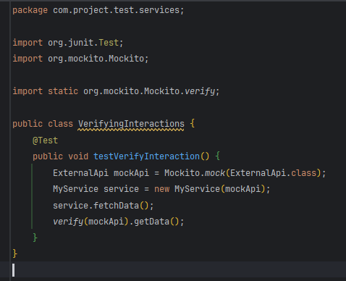

Output

